The Travelling Grandmother Tent…..
Bev, beloved Bev Reeler in her dreaming, imagining and magic making….caught the thread and began to pull on it. Out came nine women, a place of beauty in Nyanga Zimbabwe where they could gather and so began the time of the Grandmother Tent.

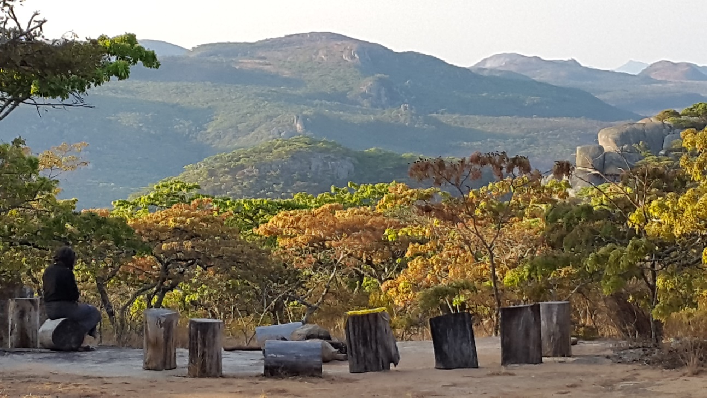

Four four days and nights we walked and talked our ribbons, marked as they were with the symbols reminding us of the events of our lives. We told some of those stories…. from the day of our birth to our current ages, decade by decade….we went.
First Decade: Our themes included: being loved and welcomed, not feeling welcome, abandonment, safe world, unsafe world, free to play, connected to nature, like the sun, having plenty, having little, hardship, ease.
Ten to Twenty: Sexuality, promiscuity, same gender relationship, the state of the nation, war, connection, friendships, shared history cross culturally, loss grief, leaving/returning, many schools, many moves, unable to bear children, marriage; happy relationship, betrayal, study, university, worklife, belonging, not belonging, leadership, rebellion, hallucinagenics, experimentation, spirituality

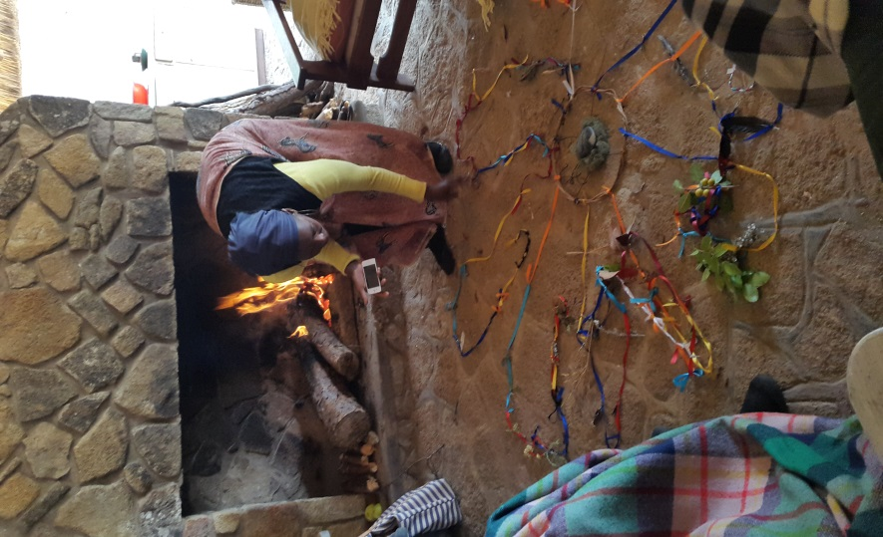
Twenty to Thirty: arrested; house bombed, first woman to join the MDC, husbands playing about; loss of possessions; family in exile; travelling in and out of Zim and the UK; study, raising children, spiritual community, giving up career.
Thirty to Forty: Divorce, new career, new relationship, children dying, new beginnings in Zimbabwe, university as an older woman, travel, educating the young ones, changing harmful cultural patterns with daughters, and on we went, the stories unfinished, as we are.
The Grandmother Tent travelled from Harare to Cape Town in a wine box bearing the name Miss Molly. We liked that. On route our creation was, to the Women Are Medicine Gathering at Cape Point in October ready for more embellishing along the way.
The following week Miss Molly travelled to the Groot Winterhoek mountains, a cob house and another nine women who were gathered for four days to explore “the Second Half of Life” We were all in our fifties and sixties. (see pic)
Our themes were refirement rather than retirement, changing relationships – from being centre to being rimholders, vibrant grandmothers and mentors… living in our changing bodies and preparing to die a good death. The Grandmother Tent hung in the middle of the room in which we laughed, cried, reflected and remembered our ancestors and those who come after us. The women wrote something to younger women which they attached to Miss Molly.
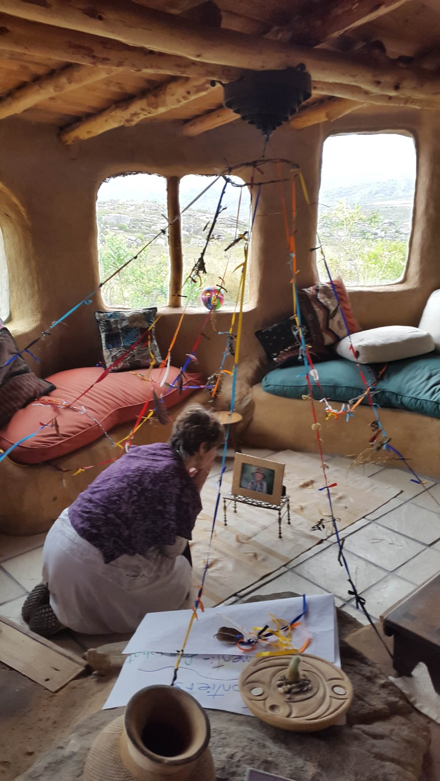

From the mountains to the West Coast, the next week end, where Judy facilitated a Rites of Passage process with 35 second year students from Tsiba Education….
What a time that was. We travelled from birth and early childhood into sexuality, sensuality and intimacy, to being a young woman in the world and dealing with matters related to power and its use, choice, money as a human current and sex. In small groups they gravitated to the theme that interested them most and then wrote their thoughts in some “blind poetry” for women who are following them. These were folded into medicine bundles and attached to the end of the Grandmother Tent.

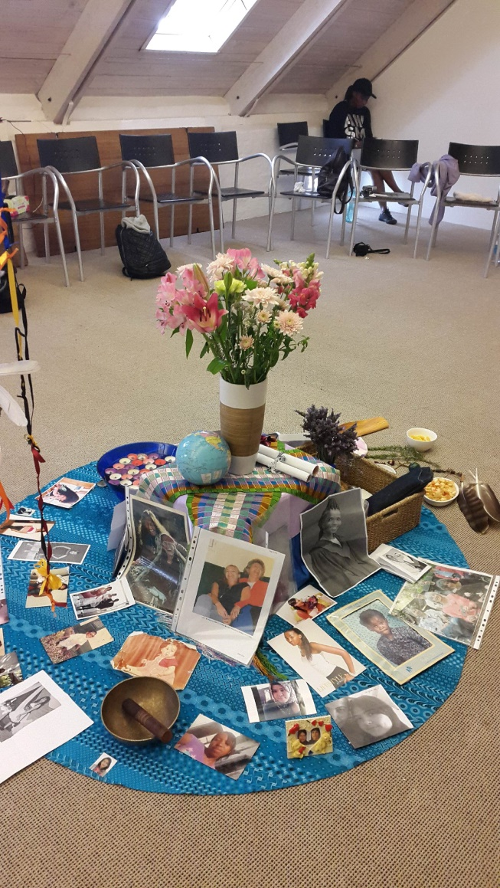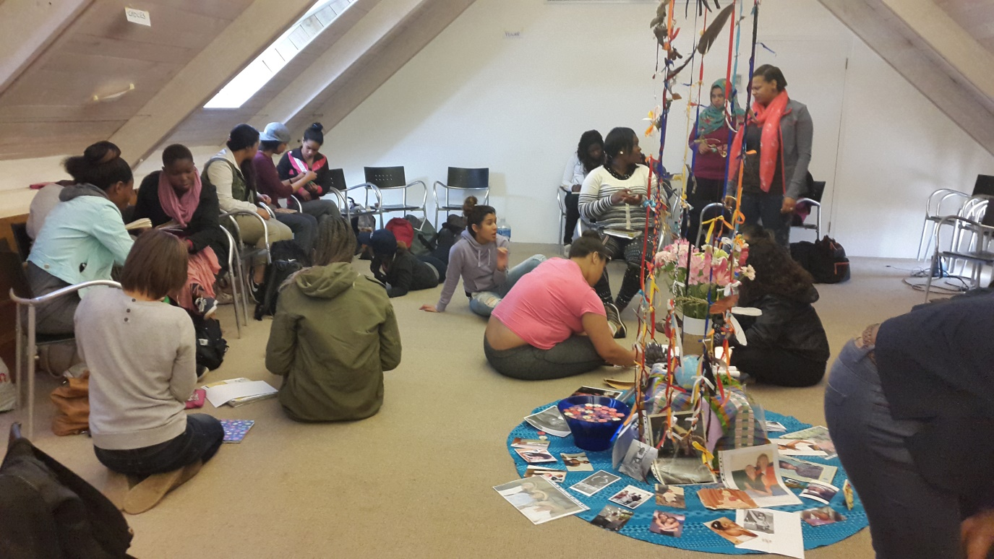

The next week Miss Molly was appreciated by a circle of elders in Cape Town who decided that we would begin to make our own Grandmother Tent and journey together through our stories with ribbon, cloth and symbols. The magic and the mystery continue as the Grandmother Tent passes through your hands and hearts….
“I would love to live the way the river flows
Carried by the surprise of its own unfolding”
- John O’Donahue

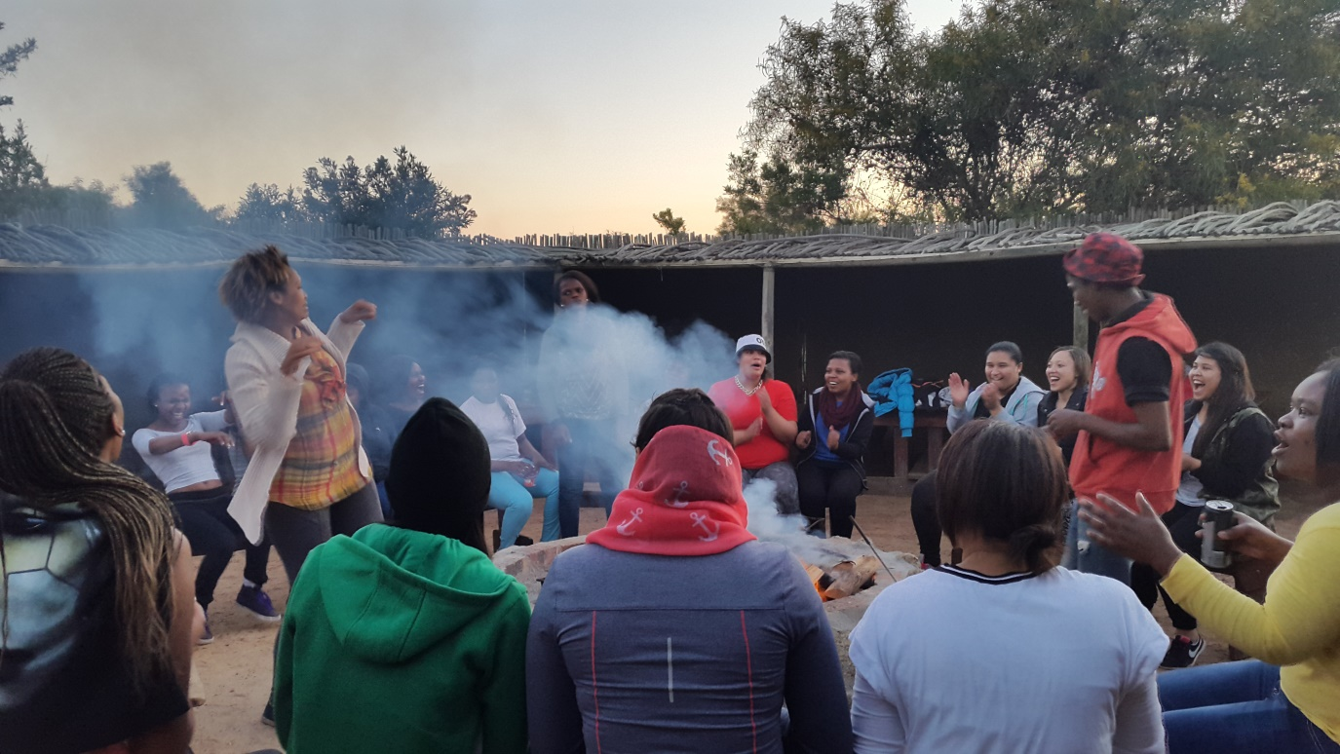

With love, always with love
Judy

